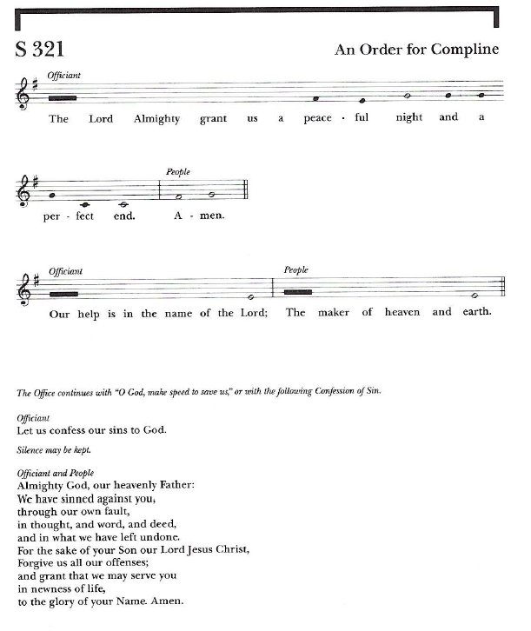

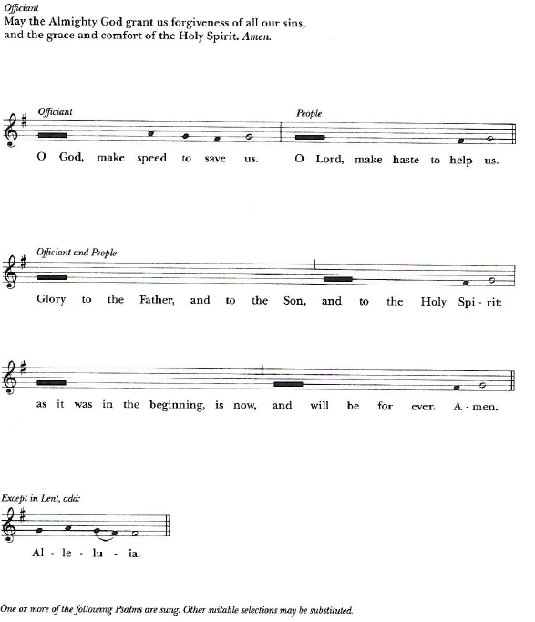

A Psalm is read or sung.

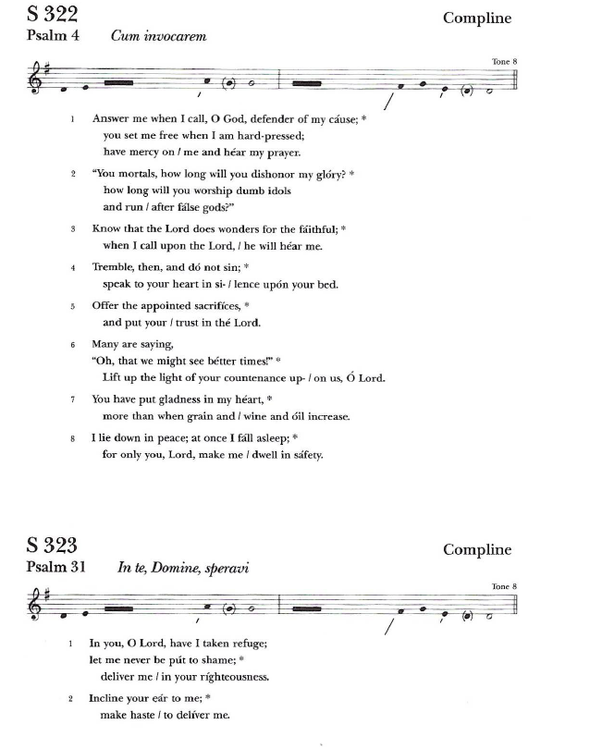
After Psalm the Gloria is sung.

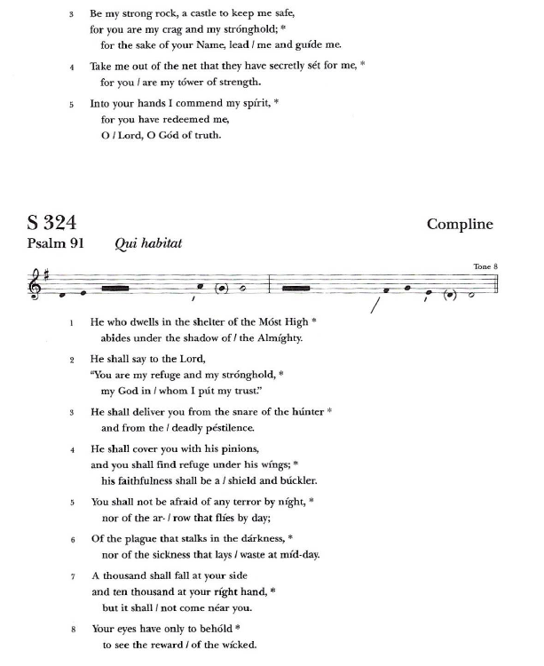
After Psalm the Gloria is sung.

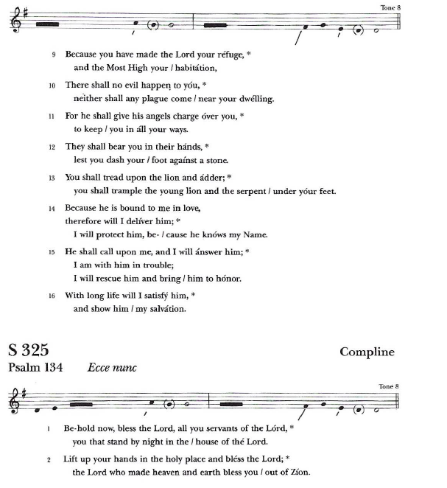
After Psalm the Gloria is sung.

After Psalm the Gloria is sung.

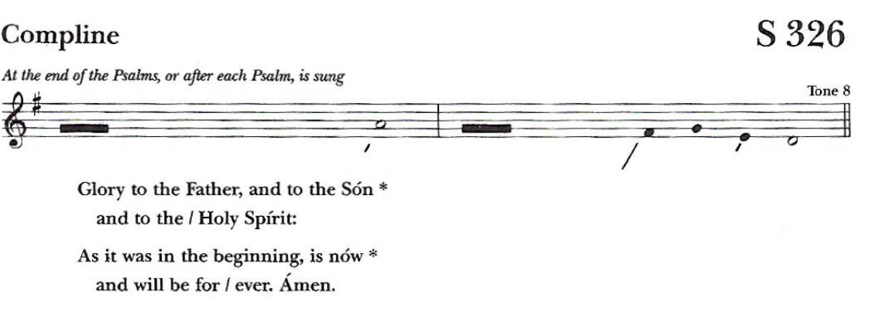

a suitable passage of scripture is read.

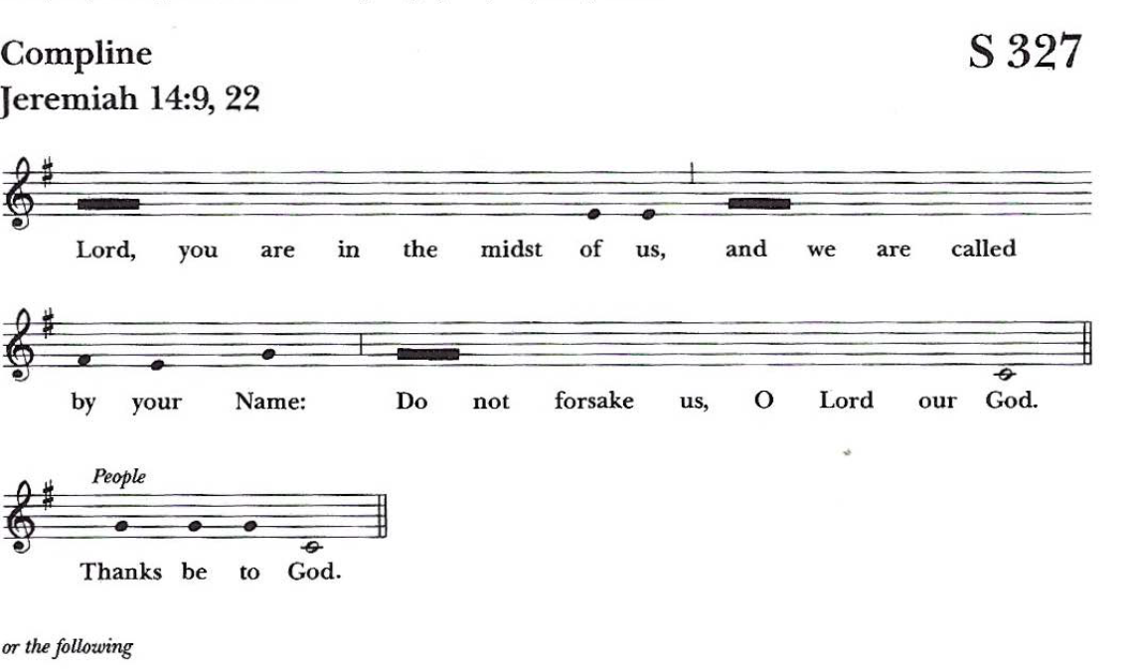

Or the following

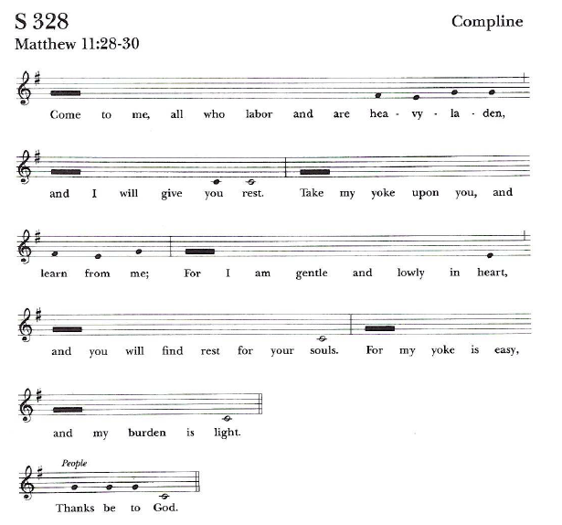

Or the following

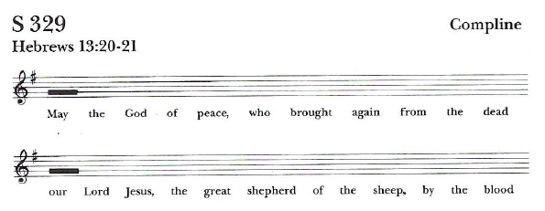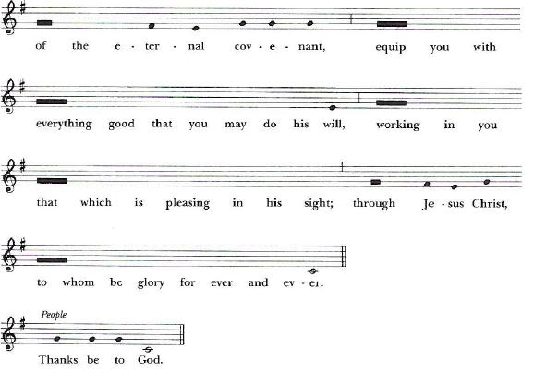

Or the following

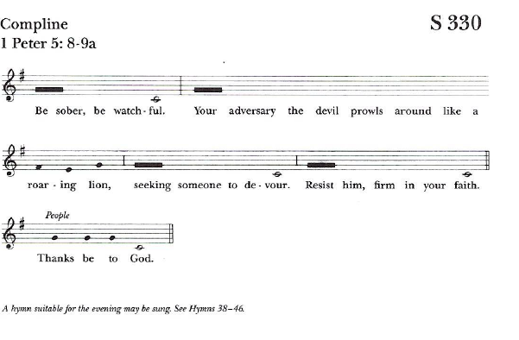

A Hymn suitable for the evening may be sung. Then follows

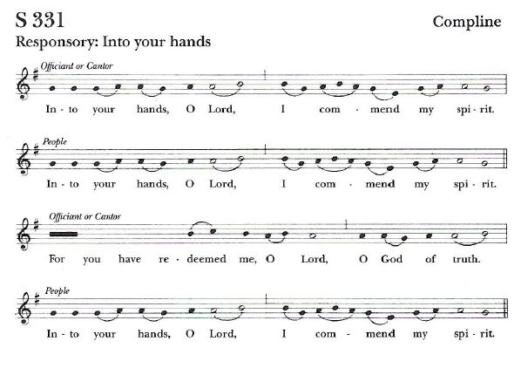
Then follows

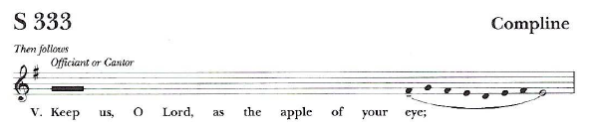
Then follows

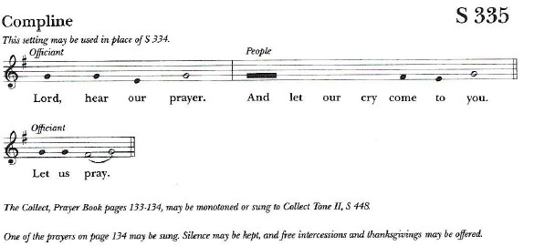
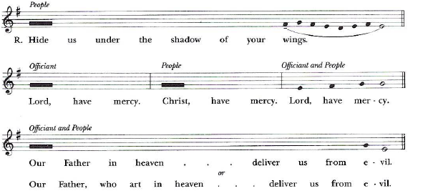

The officiant then says or monotones one of the following collects

Be our light in the darkness, O Lord, and in your great mercy
defend us from all perils and dangers of this night; for the
love of your only Son, our Savior Jesus Christ. Amen.
Be present, O merciful God, and protect us through the hours
of this night, so that we who are wearied by the changes and
chances of this life may rest in your eternal changelessness;
through Jesus Christ our Lord. Amen.
Look down, O Lord, from your heavenly throne, and
illumine this night with your celestial brightness; that by
night as by day your people may glorify your holy Name;
through Jesus Christ our Lord. Amen.
Visit this place, O Lord, and drive far from it all snares of the
enemy; let your holy angels dwell with us to preserve us in
peace; and let your blessing be upon us always; through Jesus
Christ our Lord. Amen.

The Officiant then says or monotones
Keep watch, dear Lord, with those who work, or watch, or
weep this night, and give your angels charge over those who
sleep. Tend the sick, Lord Christ; give rest to the weary, bless
the dying, soothe the suffering, pity the afflicted, shield the
joyous; and all for your love's sake. Amen.
or this
O God, your unfailing providence sustains the world we live
in and the life we live: Watch over those, both night and day,
who work while others sleep, and grant that we may never
forget that our common life depends upon each other's toil;
through Jesus Christ our Lord. Amen.

Silence may be kept, and free intercessions and thanksgivings may be offered.
The following is sung by the officiant or others
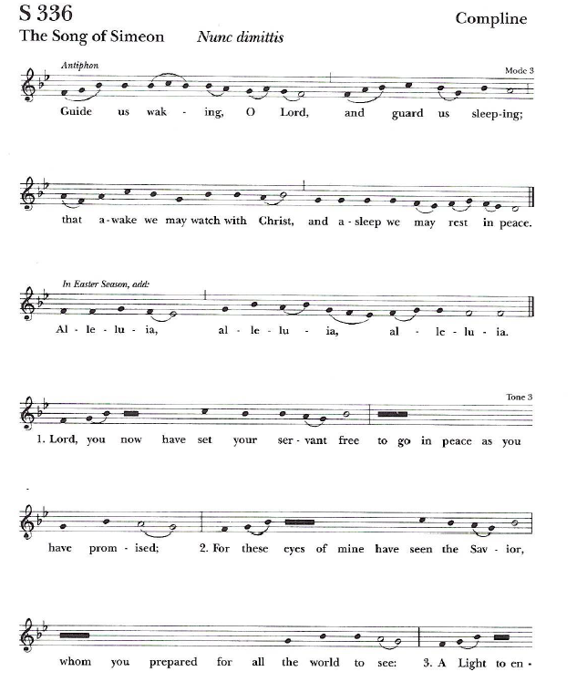

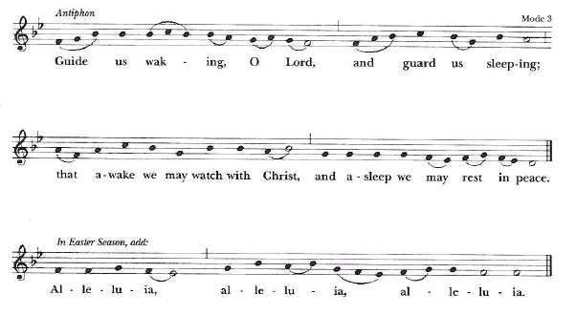
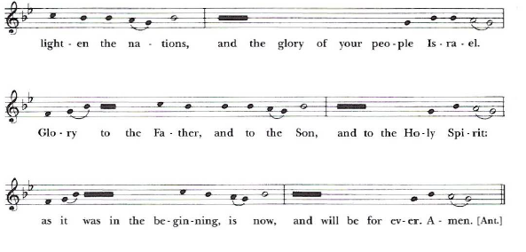

Then the following concluding versicle and blessing is sung

